**Virtual Lab 5 – Microwave Resonator**

**Pre-lab:**

1. Read textbook and lecture notes regarding microwave resonator.
2. Rogers Duroid RO4003C will be used as the substrate. (substrate thickness 31 mil, copper thickness 17 μm)

**Procedure:**

For a microwave resonator, the resonant frequency *f0* and unloaded Q factor *Qu* are the most important parameters. In this lab, you will learn how to simulate these two parameters using several different methods.

Basically, eigen mode and driven mode simulations can be used to simulate a half-wavelength microstrip resonator. Eigen-mode simulations do not require port(s). However, in eigen mode simulations, no radiation boundary is allowed. Therefore, radiation loss cannot be modeled in eigen mode simulations, which will affect the accurate modeling of *Qu*. On the other hand, in driven mode simulations, radiation boundary is allowed. Nevertheless, the driven mode simulation takes a longer time compared with eigen mode simulation. This lab walks you through different methods to understand the physics of microwave resonators and accurately characterize their performance.

**Method 1: Eigen mode simulations**

Draw the resonator with the following dimensions:

* Roger RO4003C substrate dimensions: 16×50×1.57 mm3
* Air box dimensions: 16×50×15 mm3
* Microstrip resonator dimensions: 3.5mm × 16mm × 17 µm (right on top of the substrate)
* Set the material of the microstrip resonator to be copper.
* Select the bottom of the substrate and set the boundary to be finite conductor (copper)
* Set the boundary for the top surface and four sidewalls as PEC. In fact, the default setting is already PEC.
* Under this configuration, the microstrip resonator is simulated inside a metal box (no radiation loss).
* Select HFSS🡪Solution Type🡪Eigenmode. Right click Analysis🡪Add Solution Setup and set the Eigen Solution Setup as shown below and run the simulation.

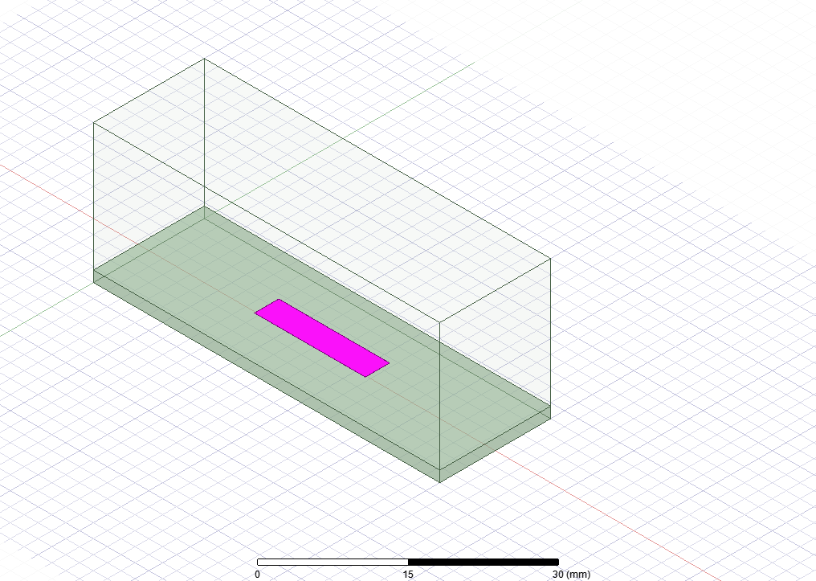 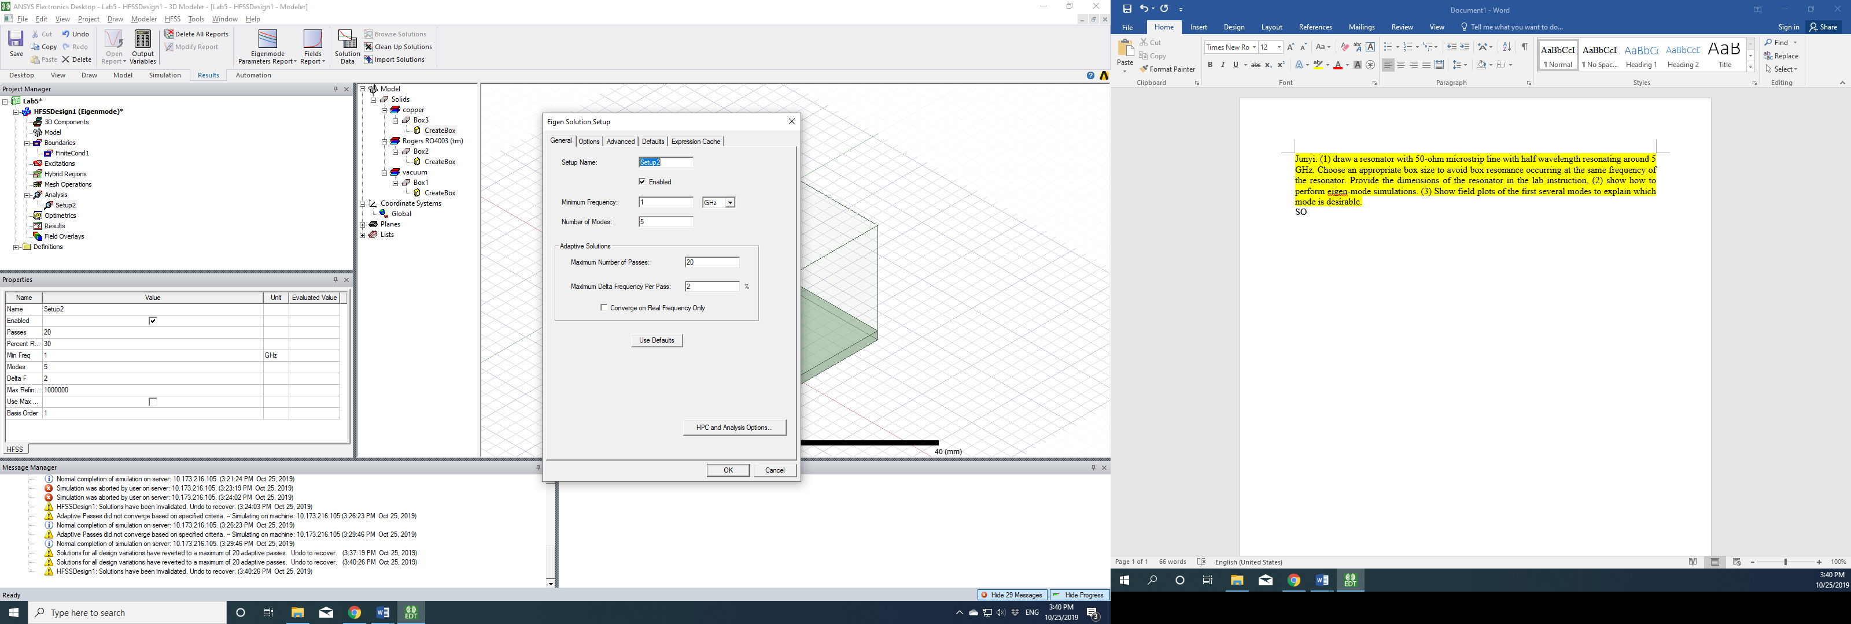

After the simulation is completed, click the Solution Data, you can see the first five modes in this structure. In order to identify which mode corresponds to the microstrip resonator, you need to plot the field for the five modes as shown below. Mode 1 is from the resonance of the microstrip resonator. Mode 2 is called box resonance since the field is mainly in the air. The unloaded Q factor of the mode 2 is very high, i.e. 3848, which is too high for a microstrip line resonator (think about the loss mechanism of a microstrip resonator). You can plot the field for different modes by changing the mode (HFSS🡪Fields🡪Edit Sources). Mode 3 seems like another box mode but with a much lower unloaded Q factor. In practice, you always calculate the resonant frequency of the microstrip resonator beforehand to guide your search of the correct resonance.

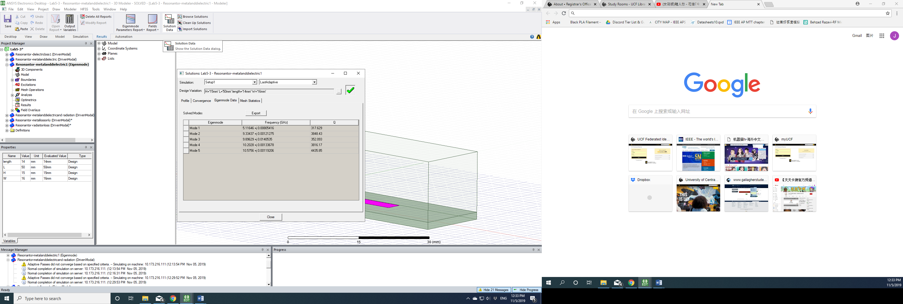

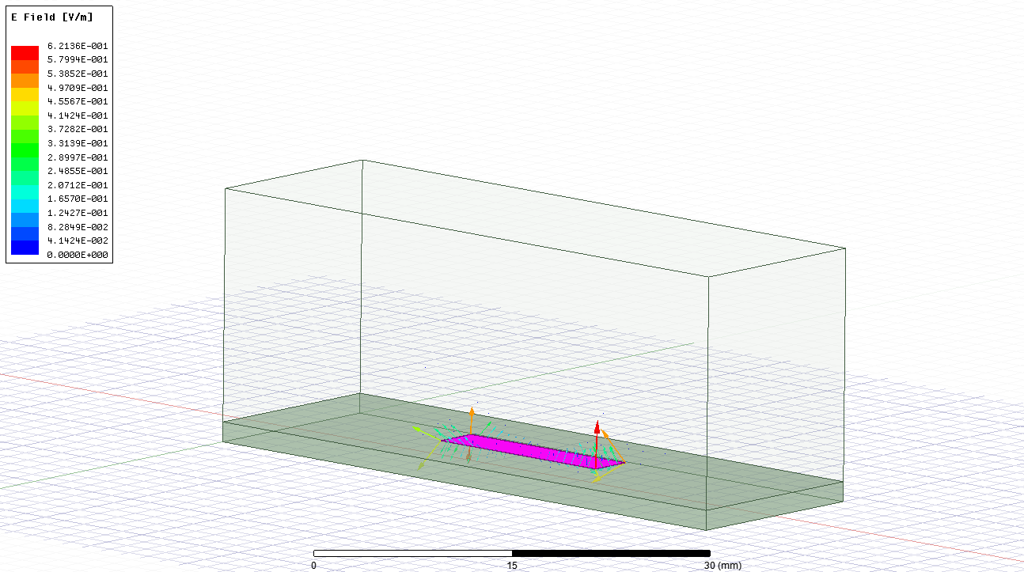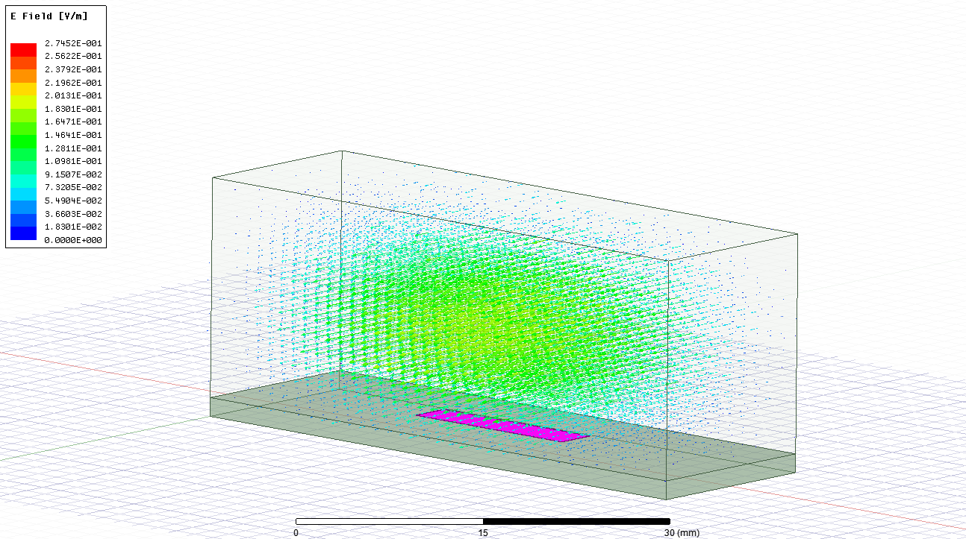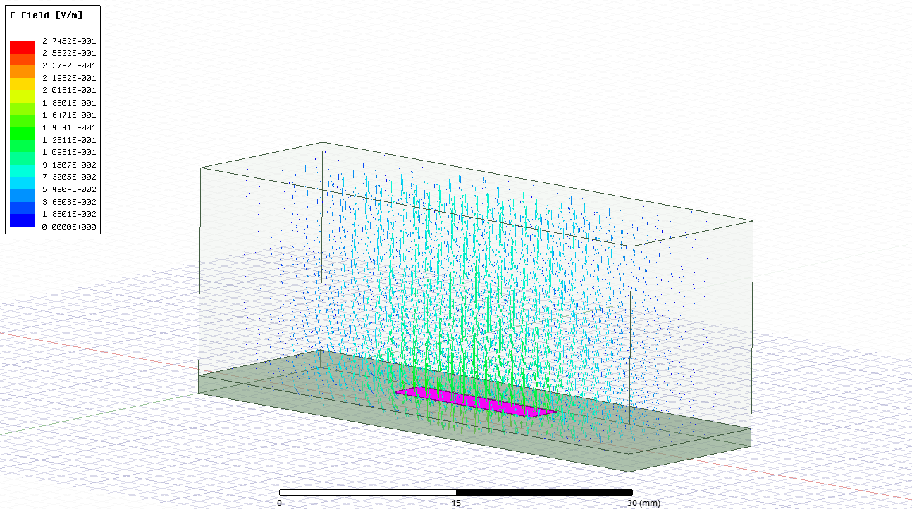

Mode 1 Mode 2 Mode 3

Though it is nice to simulate multiple modes at a time, the simulation results are not the most accurate. It is best to simulate one mode only in HFSS to achieve the best result. Since we know the microstrip resonator has a resonant frequency of ~5.116 GHz, we can set the minimum frequency in the “eigen solution setup” to be slightly lower than 5.116 GHz and then set the number of modes to be 1. In the solution setup, set Max. Delta frequency to a very small number and set the number of passes to 20. Then increase the number of passes by 2 , 4, 6 … and check if the resonant frequency and unloaded Q are converged. Provide a table in your report to justify your results. Report the resonant frequency and unloaded *Q* factor **(Method 1)**. To summarize, method 1 simulates the resonant frequency of the resonator very accurately. While for the unloaded Q factor, it includes the metallic and dielectric losses not but the radiation loss. However, if you place the resonator inside a metal box (package), then the eigen mode simulation is perfect for this case.

**Method 2: Driven mode simulations without radiation boundary**

In driven mode simulations, radiation boundary can be assigned to capture the radiation loss. In addition, we need to **weakly** excite the resonator with two microstrip lines. This weak excitation is necessary to minimize the detuning of the resonant frequency of the resonator. If the gap between the feeding microstrip line and resonator is too small, the simulated resonant frequency is lower than the actual resonant frequency of the resonator. In eigen mode simulations, you never need to worry about this.

Change the simulation to driven mode (HFSS🡪Solution Type🡪Modal). Add a 50-ohm microstrip line (3.5mm wide) at both sides of the resonator as shown below. Assign two ports. The gap between the resonator and the feeding microstrip line should be > 3 mm. After you perform the simulations, S21 should be <-20 dB, which implies that the excitation is indeed **weak**. The two transmission lines are set to copper as well. The boundary condition for the top surface and two sidewalls is set to be PEC (Method 2). In this setup, there is no radiation boundary. As a result, the simulated unloaded Q factor should reflect metallic and dielectric losses only, like in Method 1. Check the convergence as mentioned earlier. Provide a table in your report to justify your results.

Wave Port 1

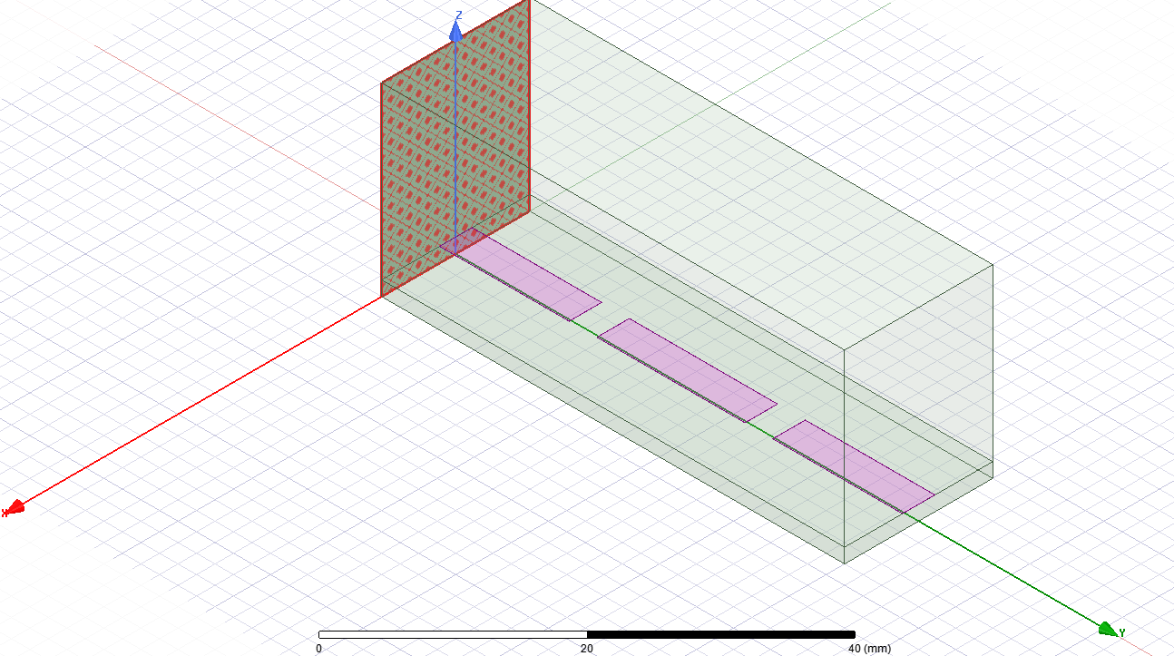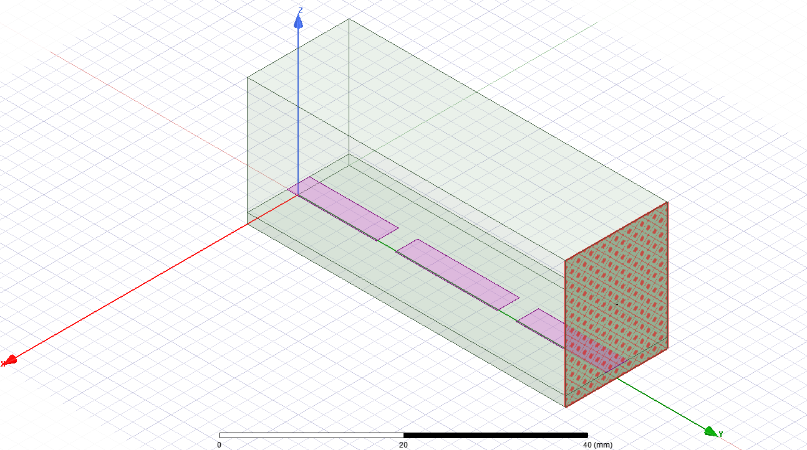

Wave Port 2

The unloaded Q factor is not directly readable. What you can find in the S21 plot is loaded Q factor which is given by , in which and correspond to frequencies at which S21 is 3 dB below the peak value. is the parallel combination of (loss inside the resonator) and the external Q factor (loss due to the coupling to the ports).

A useful formula to calculate from is given below:

In which is the maximum value at . The weak coupling has two advantages here: (1) the simulated *f0* is very close to the resonant frequency of the resonator; and (2) the *Qu* is insensitive to the measurement uncertainties in terms of ||. This method has been widely used in characterizing microwave resonators since this driven mode structure can be fabricated and measured.

**Method 3: Driven mode simulations with radiation boundary:**

Set the top surface to radiation boundary and repeat the procedure in Method 2. (Method 3)

**Identify different contributions of losses.**

HFSS allows you to find the losses due to metal, dielectric and radiation, respectively. Using the driven mode setup, perform three separate simulations: (1) with metal loss only, (2) with dielectric loss only and (3) with radiation loss only.

**Lab Reports:**

1. (20 pts) Report the results using Method 1. You need to present your own versions of structure drawing, field plots, convergence table, and etc.
2. (20 pts) Report the results using Method 2 with all necessary details.
3. (20 pts) Report the results using Method 3 with all necessary details.
4. (10 pts) Report the Q factors due to three loss mechanisms. When you combine all three unloaded Q factors in parallel, does it agree with the total unloaded Q factor with Method 3?
5. (10 pts) In Method 4, you will use analytical formulas to calculate the *f0* and *Qu*. By today’s standard, it is no longer considered accurate. However, it is beneficial for you to see how things were done in the past and how accurate/inaccurate this method is. Find the effective dielectric constant of the microstrip line using the formula in the textbook and use it to estimate the resonant frequency of the half-wavelength resonator. This frequency is typically higher than the HFSS simulation results. The difference is due to the fringing field effect at the two ends of the resonator. The actual resonator is equivalent to an ideal transmission line loaded with two identical capacitors at both ends. Calculate the capacitance. In addition, you can find the using Pozar’s methods for the attenuation and the propagation constant. Follow example 6.2 in Pozar’s book. It is noted that radiation losses are not considered in this case.
6. (10 pts) You can also find the effective dielectric constant, attenuation and the propagation constants in HFSS Ports-only simulations. Report *f0* and using this method (Method 5)?
7. (10 pts) Compare the *f0* and by all 5 methods in a table and comment.